Linear equations and inequalities
Monday, June 3, 2019
12:03 PM

1. A line passes through (2, 9) and has a zero slope. Write an equation of the line satisfying the given conditions.
A. y = 2
B. x = 2
C. x = 9
D. y = 9

2. Which of the following is a linear equation?
A.
B.
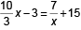
C.
D.
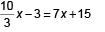

3. A/An _______ is a statement indicating that two expressions are equal.
A. expression
B. equation
C. identity
D. contradiction

4. The S-Cargo shipping company calculates shipping charges using the linear model, y = 2.72x, where y is the cost in dollars and x is the weight of the package in pounds (1 ≤ x ≤ 9). Use the linear model to compute the weight of a package with a shipping cost of $21.76. Round to the nearest hundredth of a pound, if necessary.
A. 10.72 lb
B. 2.94 lb
C. 21.76 lb
D. 8.00 lb

5. Determine the slope and the y-intercept of the line 7x + 3y = –8.
A.
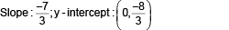
B.
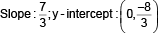
C.
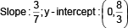
D.
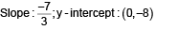

6. Solve the inequality. Write the answer in interval notation.
–2 < –2y + 19 < 10
A.
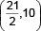
B.
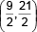
C.
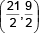
D.
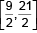

7. A line contains the point (–3, –4) and is perpendicular to a line with a slope of
. Write an equation of the line satisfying the given conditions. Write the answer in slope-intercept form.
A.
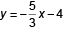
B.
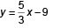
C.
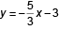
D.
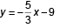

8. Solve the equation:
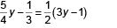

A.
B. y = 0
C. y = –10
D.
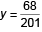

9. Which of the lines defined here has/have only one unique intercept?
A. x = 8
B. –8x – 7y = –7
C. 9y = 5
D. –3x – 3y = 0
A. A., C., and D.
B. A. and C.
C. B.
D. B. and D.

10. Graph the linear equation: y = –x + 3
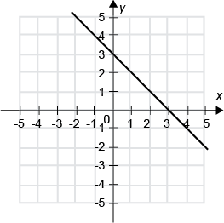
A.
B.
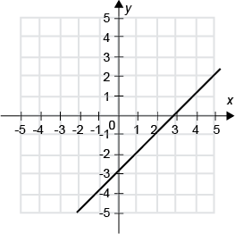
C.
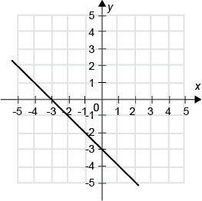
D.
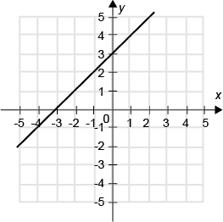

11. Solve the inequality. Write the answer in interval notation.
5x ≤ 10 or 15 – x < 7
A. {}
B. (–∞,∞)
C. (–∞,2] ∪ (8, ∞)
D. (–∞,8)

12. Identify the inequality that matches the graph.
A. |x + 1| > 6
B. |x – 1| > 3
C. |x – 1| > 6
D. |x + 1| > 3

13. Use the slope formula to determine the slope of the line containing the two points (4, –8) and (–1, –2).
A.
B.
C.
D.

14. A tool rental store charges a flat fee of $9.50 to rent a chain saw, and $3.75 for each day, including the first. Write an equation that expresses the cost y of renting this saw if it's rented for x days.
A. y = 9.50x + 3.75
B. y = 3.75x – 9.50
C. y = 3.75(x + 9.50)
D. y = 3.75x + 9.50

15. Graph the linear equation: 3y = –2x – 1
A.
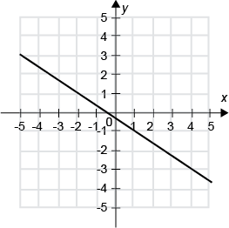
B.
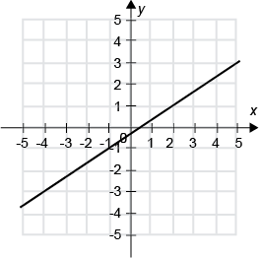
C.
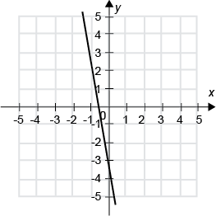
D.
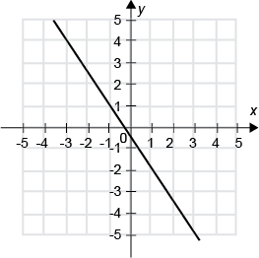

>
16. Solve the absolute value equation.
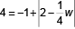

A. {–28, 12}
B. {12}
C. {–12, 28}
D. {–28}

17. Use substitution to determine which value is the solution to 5x + 3 = 18.
A. x = 3
B. x = 1
C. x = 9
D. x = 2

18. Solve the equation:
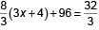

A. x = 8
B. x = –12
C. x = 12
D. x = –10

19. Find the slope of the line determined by the equation 2x = y.
A. m = –2
B. m = –3
C. m = 3
D. m = 2
20. The sum of two consecutive even integers is 158. Find the least of the two integers.
A. 78
B. 156
C. 80
D. –78

